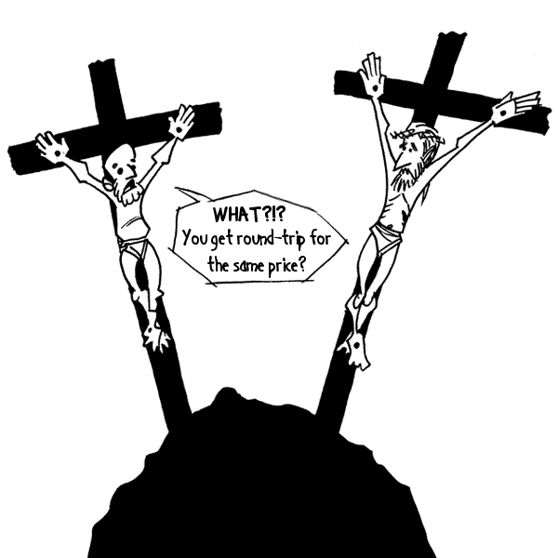
Jesus Stubbed His Toe for Your Sins

March 15 2008
apost8n8

Imagine with me that an elderly man approaches you with the promise of an additional 100 years of perfectly happy life if you only had to experience horrible pain for one hour. Imagine somehow this was a guaranteed deal with no strings attached or hidden agendas. Any ounce of skepticism you might have could be met with satisfactory answers and evidence. Would you do it? Would a relatively small amount of pain for 1 hour be worth the guarantee of thousands and thousands of wonderful days to follow?

Here’s another thought. Imagine that your bank account balance has more figures in it than you can count. Let’s say that you make Bill Gates look like a third-world beggar. Imagine you have the opportunity to donate $10,000,000 to a charity that could somehow guarantee to end all disease in children. Let’s say somehow it was really a sure thing. Not maybe, not with lots more work, but your action ensures the outcome. Would you go ahead with it? Sure it might mean you can’t put those gold plated toilet seats in you private 777, but you’d probably go ahead and do it, right? While it’s a nice gesture, is it really that worthy of praise? In fact I’d say if you didn’t do it you should be considered a pretty horrible person.

What if you happened to be the son of God, the actual creator of the universe? What if you have existed forever and know that you will continue to exist forever. If you were given the chance to save thousands, millions, or billions of people from suffering by subjecting yourself to temporary pain and suffering would you? What are a few days of suffering for a being that exists for all eternity? It’s really not such a sacrifice to spend an infinitesimally small amount of your existence in pain when there is so much to be gained for it. In fact it’s no sacrifice at all when you know that you will survive it and the pain will end and you will continue in bliss.

John 10:17 - King James Bible
Therefore doth my Father love me, because I lay down my life, that I might take it again. (Unconditional love, huh?)

Jesus did not DIE for humanity’s sins; it’s more like he stubbed his holy toe. This is the extent of his sacrifice. A stubbed toe is the equivalent of this most sacred act so central to the core of Christianity. This is the act that is said to redeem all of the world’s most horrible instances of cruelty, injustice and depravity.

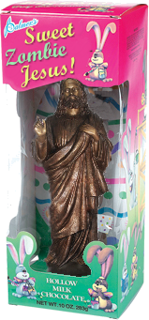
While there is certainly much skepticism about the reality of Jesus’ life, it is historical fact that thousands of real men died on the cross. These were real people that were never going to rise again to live for all eternity. Many of whom probably went up on the cross as a sacrifice for some cause or loved ones with no promise of resurrection or even martyrdom. What of their sacrifice? Who remembers those that truly sacrificed everything? In comparison to Jesus’ empty gesture of faking his own death, the dying act of those countless nameless other Roman victims is much more worthy of respect.

I tire of hearing about the ultimate sacrifice that Jesus supposedly made for each of us. The whole story is designed to give you guilt. The idea is that you should believe these irrational stories because you are guilty that someone already paid your way. Guilt and fear are the foundations of faith.

So this Easter, when your local churches are so eager to remind you that the day isn’t about colored eggs and that the Easter bunny didn’t die for your sins, you must also remember that the ultimate Fortunate Son didn’t either.

Since you’re here… This doesn’t even address the hundreds of other criticisms with this central story of Christianity. Why does the creator need blood sacrifice at all? If god is all powerful then isn’t this all just a magic show, an illusion, a lie? Please read the stories yourself: See Matthew 28, Mark 16, Luke 24, John 20-21, Acts 1:3-12, and I Corinthians 15:3-8. See if any of it makes since while remaining intellectually honest? Why do these biblical accounts differ? Could it be that the bible is not literal? Could it be that the bible is written by man instead of God? Think for yourself!
